2024 Volunteer Appreciation Email Template

Instructions:
- Open your favorite email program and create a new email. Be sure to enter the email address of the volunteer your Girl Scout would like to recognize into the “To” field.
- Copy, paste, and customize the [red sections] of the subject line and message body or create your own. Here are some questions you can ask your Girl Scout to get you started:

Who is your favorite Girl Scout leader?

What did you most appreciate this leader doing for your troop this year?

What have you gained the confidence to do this year?

What was your favorite memory from Girl Scouting this year?

Put the final touches on the email by including the header image with the email. To do that, save or copy the image onto your device, then paste, insert, or attach the image into the email.

Once you’re done, send it to a volunteer to show your appreciation!

Subject Line: A big thank you from [Your Name]!

Header Image:
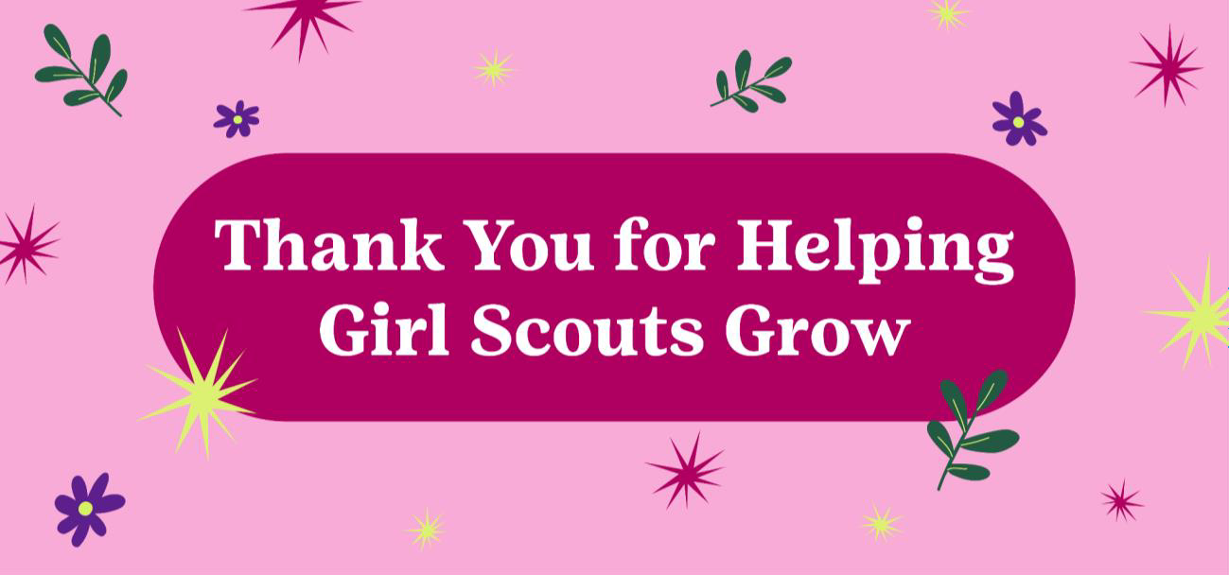

Message Body:
Dear [Volunteer Name],

Happy Volunteer Appreciation Month! I wanted to reach out and personally thank you for helping [Girl Scout’s First Name] grow and thrive this year.

She really appreciated when you [Details Here]! Thanks to your guidance and support, she has felt confident enough to [Details Here]. Her favorite memory with you this year was [Details Here].

I’m really glad that you’re her [Volunteer Position Title e.g. Troop Leader, Cookie Volunteer, etc.]. Thanks for all you do!

Sincerely,
[Girl Scout’s First Name and Last Initial]’s caregiver

