Girl Scout Fall Recruitment – It’s Time to Press Play
Social Media Toolkit: Renew
Graphics with Posts

Introduction
The below sample messaging is intended for use across social media platforms.

Please note: This document shows which graphic goes with each post. When posting, please use the high-resolution graphic/image in the image file, not the low-resolution graphic presented here.

Emojis:
👩🏽‍🤝‍👩🏼 ✅ ⭐⚡
👧👧🏻👧🏼👧🏽👧🏾 👏🏻👏🏼👏🏽👏🏾👏 💪🏼💪🏽💪🏽💪🏾💪 🙌🏻🙌🏼🙌🏽🙌🏾🙌🏿🙌

Facebook: After hitting pause last year, she can now press play and continue her journey with #GirlScouts. Renew today. www.gsnetx.org/renew
Instagram: After hitting pause last year, she can now press play and continue her journey with Girl Scouts. Click link in bio to renew today. #GirlScouts [ADD www.gsnetx.org/renew LINK IN BIO].
Twitter: After hitting pause last year, she can now press play and continue her journey with #GirlScouts. Renew today. www.gsnetx.org/renew

Facebook:
Connect with friends.✅
Try new adventures. ✅
Change the world. ✅
Don’t miss out: renew your membership today. www.gsnetx.org/renew
Instagram:
Connect with friends. (Check emoji)
Try new adventures. (Check emoji)
Change the world. (Check emoji) Don’t miss out: renew your membership today. Hit link in bio to learn more. [ADD www.gsnetx.org/renew LINK IN BIO]
Twitter:
Connect with friends. (Check emoji)
Try new adventures. (Check emoji)
Change the world. (Check emoji) Don’t miss out: renew your membership today. www.gsnetx.org/renew #GirlScouts

Facebook: If she’s ready to make new friends, take on new adventures, and change the world, Girl Scouts is ready for her! (arrow emoji) www.gsnetx.org/renew
Instagram: If she’s ready to make new friends, take on new adventures, and change the world, #GirlScouts is ready for her! Link in bio. (wink emoji + link emoji) [ADD www.gsnetx.org/renew LINK IN BIO]
Twitter: If she’s ready to make new friends, take on new adventures, and change the world, #GirlScouts is ready for her! (arrow emoji) www.gsnetx.org/renew

Facebook: After hitting pause last year, it’s time to press play and keep the adventures going with Girl Scouts. Let her continue connecting with friends and changing the world––let’s go (point emoji) www.gsnetx.org/renew #GirlScouts
Instagram: After hitting pause last year, it’s time to press play and keep the adventures going with Girl Scouts. Let her continue to connect with friends and change the world––let’s go! Click link in bio to renew. [LINK www.gsnetx.org/renew IN BIO] #GirlScouts
Twitter After hitting pause last year, it’s time to press play and keep the adventures going with Girl Scouts. Let her continue connecting with friends and changing the world––let’s go (point emoji) www.gsnetx.org/renew #GirlScouts

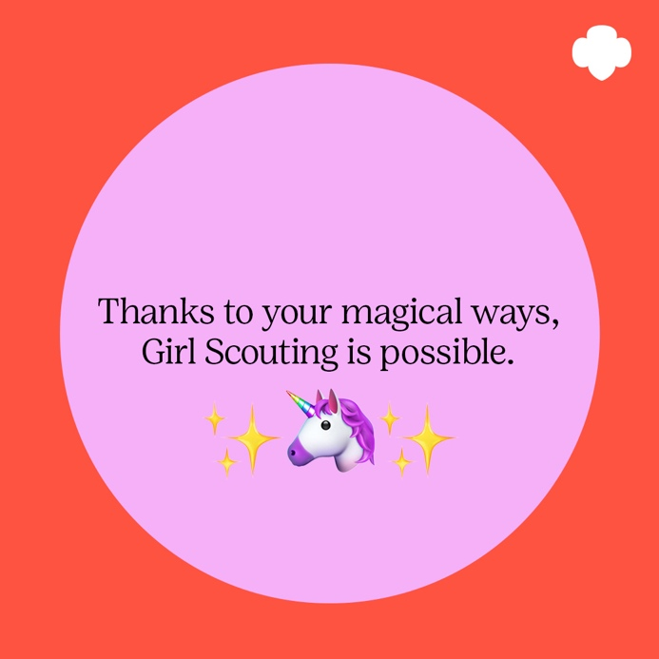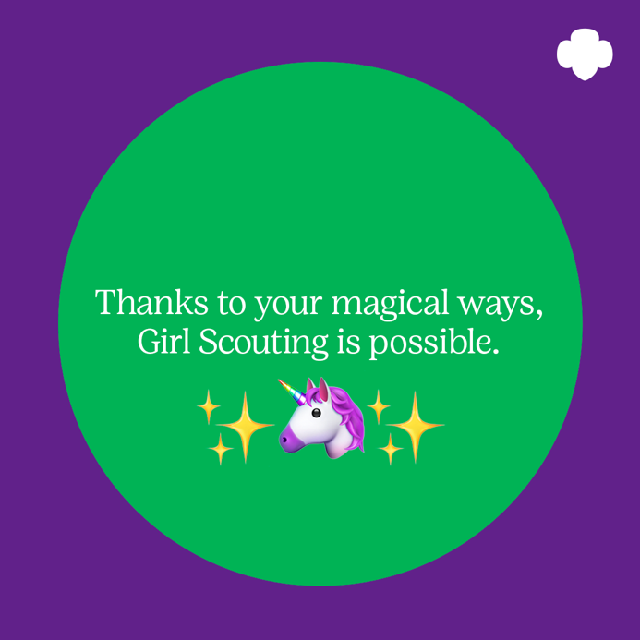

Facebook: Girl Scout volunteers: continue to be their champion! Renew your Girl Scout membership today. www.gsnetx.org/renew
Instagram: Girl Scout volunteers: continue to be their champion! Click link in bio to renew your Girl Scout membership today. [ADD www.gsnetx.org/renew LINK IN BIO] #GirlScouts
Twitter: Girl Scout volunteers: continue to be their champion! Renew your Girl Scout membership today. #GirlScouts www.gsnetx.org/renew

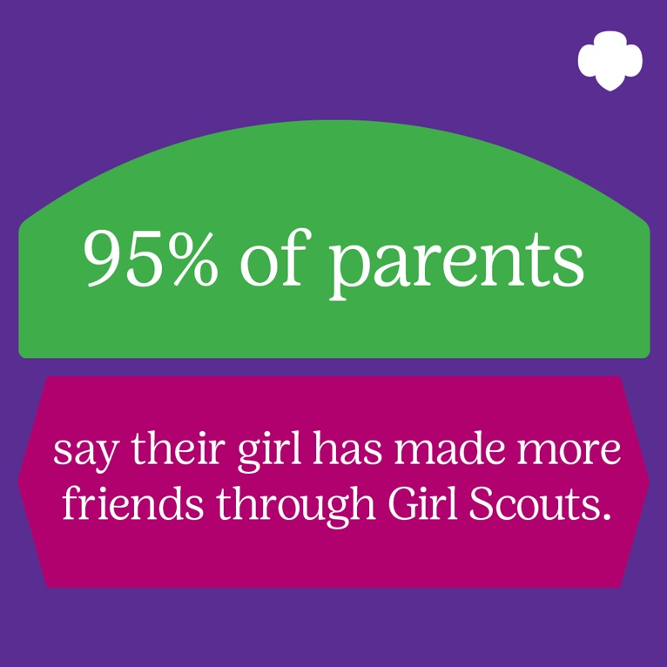
Facebook: Keep lifelong friendships and new adventures going strong. Join Girl Scouts: www.gsnetx.org/renew
Instagram: Keep lifelong friendships and new adventures going strong. Click link in bio to join #GirlScouts [ADD www.gsnetx.org/renew LINK IN BIO]
Twitter: Keep lifelong friendships and new adventures going strong! Join #GirlScouts today: www.gsnetx.org/renew

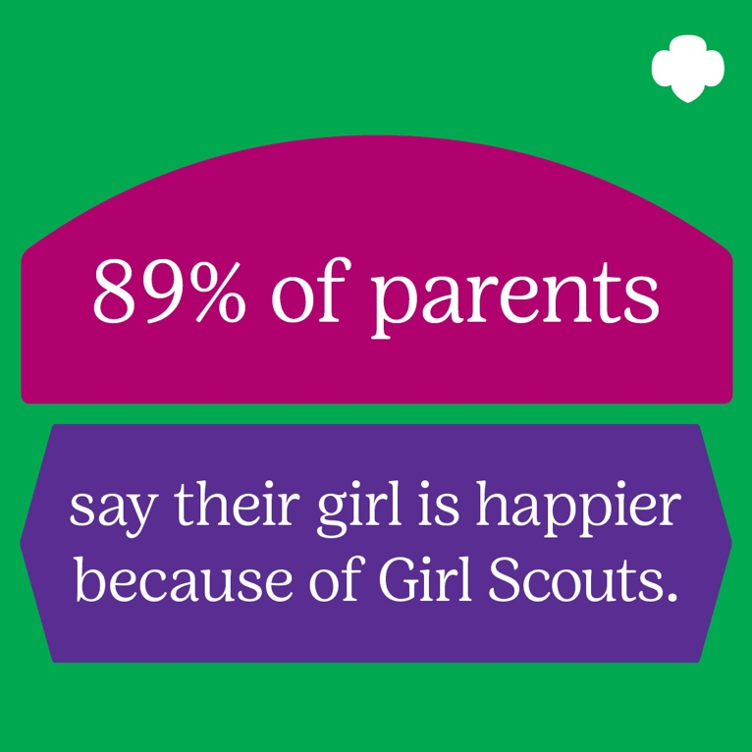
Facebook: Renew her membership today. www.gsnetx.org/renew
Instagram: Hit link in bio to renew her membership today. #GirlScouts [ADD www.gsnetx.org/renew LINK IN BIO]
Twitter: Renew her membership today. #GirlScouts www.gsnetx.org/renew

Facebook: You’ve encouraged them to make new friends, face their fears, and take on the world! Continue to champion today’s and tomorrow’s leaders. Renew your volunteer membership today (heart + arrow emoji) #GirlScouts www.gsnetx.org/renew
Instagram: You’ve encouraged them to make new friends, face their fears, and take on the world! Continue to champion today’s and tomorrow’s leaders—renew your volunteer membership today (heart + arrow emoji) #GirlScouts [LINK www.gsnetx.org/renew IN BIO]
Twitter: You’ve encouraged them to make new friends, face their fears, and take on the world! Continue to champion today’s and tomorrow’s leaders—renew your volunteer membership today (heart + arrow emoji) #Volunteer #GirlScouts www.gsnetx.org/renew

Facebook: Renew as a volunteer for another year of new adventures together. www.gsnetx.org/renew
Instagram: Renew as a volunteer for another year of new adventures together. Link in bio. #Volunteer #GirlScouts [ADD www.gsnetx.org/renew LINK IN BIO]
Twitter: Renew as a volunteer for another year of new adventures together. #Volunteer #GirlScouts www.gsnetx.org/renew

Facebook: Spend more quality time with your girl, make new friends, and change the world! www.gsnetx.org/renew
Instagram: Spend more quality time with your girl, make new friends, and change the world! #Volunteer #GirlScouts [ADD LINK IN BIO]
Twitter: Spend more quality time with your girl, make friends, and make a difference. #Volunteer #GirlScouts [COUNCIL NAME/LINK/TWITTER HANDLE]

Facebook: #DYK 95% of parents say their girl has made more friends through Girl Scouts? Keep building bonds that last a lifetime: renew today. (wink emoji) [COUNCIL NAME/LINK/TWITTER HANDLE]
Instagram: #DYK 95% of parents say their girl has made more friends through Girl Scouts? Keep building bonds that last a lifetime: renew today. Link in bio. (wink emoji) [ADD LINK IN BIO]
Twitter: #DYK 95% of parents say their girl has made more friends through Girl Scouts? Keep building bonds that last a lifetime: renew today. (wink emoji) [COUNCIL NAME/LINK/TWITTER HANDLE]

Facebook: Renew today and watch your troop’s confidence soar. [COUNCIL NAME/LINK/TWITTER HANDLE]
Instagram: Renew today and watch your troop’s confidence soar. Click link in bio for more details. #Volunteer #GirlScouts [ADD LINK IN BIO]
Twitter: Renew today and watch your troop’s confidence soar. #Volunteer #GirlScouts [COUNCIL NAME/LINK/TWITTER HANDLE]

