SAMPLE
Troop Agreement Acknowledgement

Girl Scout Troop #______ has voted on and decided to adopt the attached Troop Agreement for all Girl Scouts and volunteers and anyone else participating (e.g. siblings, parents, relatives, non-Girl Scout friends, etc).

Parents/Caregivers: Girl Scouts are asked to read through the attached document; read to their Girl Scout, if applicable. Afterwards, sign your name and have your Girl Scout sign her name in the blank provided below (if your Girl Scout is not writing yet then have her do her best), and then return this form to your troop leader. Please return only this form; the attached Troop Agreement document is yours for future reference.

I have read, understand, and agree to abide by
the guidelines of the Troop Agreement.
By adhering to these rules,
I realize that the troop will run more smoothly and safely.
I understand that failure to follow the guidelines listed
may result in my having to leave the event, meeting, or activity.

__________________________________________ _________________
Adult / Parent / Legal Guardian Date

__________________________________________ _________________
Girl Scout Date

SAMPLE 2019-2020 Troop # ______ Agreement

The mission of the Girl Scouts is to build girls with courage, confidence and character to make the world a better place. This year, our hope is to provide just such an environment for all the girls in our troop.

In this spirit, we wish to establish a troop “Code of Conduct” modeled from the Girl Scout Law.

CODE OF CONDUCT
Becoming a Girl Scout is easy; living up Girl Scouting’s ideals is harder. As a troop, we’re setting the stage for each of our Girl Scouts to succeed. To do so, all she needs is a positive attitude, determination to see things through, and self-discipline. We believe all these things can be achieved, and they can be done by following the Girl Scout Promise and the Girl Scout Law:

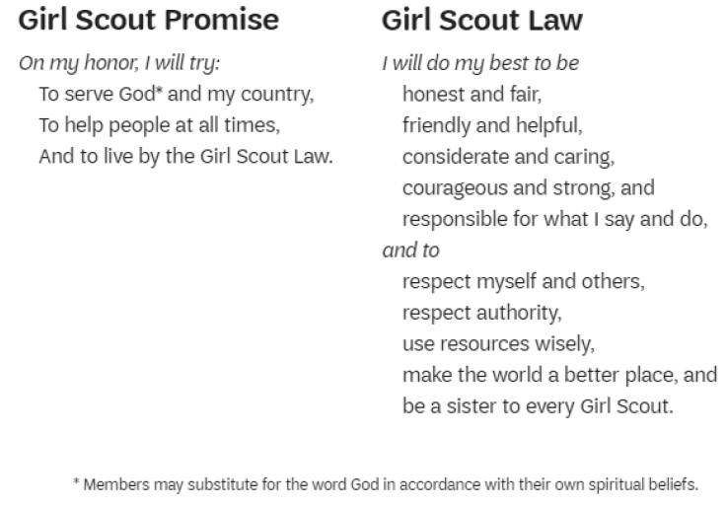

I will do my best to:
- Be truthful and not lie to my leaders and other Girl Scouts.
- Be nice to others and help when I am asked or when I see someone in need.
- Show kindness to everyone. I will not put myself down or make fun of others.
- Stand up for what I know is right. I will go to my leader if I see something happen I know is not right.
- Keep my promise if I say I will do something or won’t do something. I will be responsible for my personal belongings and equipment.
- Listen and do as I’m told by my leaders and parents. I will wait my turn and not cut in line.
- Take only what I need and will not waste supplies, materials, or time by not paying attention to instructions.
- Respect and have fun with every Girl Scout I meet. During meetings and events we are all friends and no one is to be excluded, and no disrespectful or hurtful behavior or words will be permitted between Girl Scouts. I will follow the buddy system and tell an adult before leaving the designated meeting or event area.
- Leave places better than I found them. Normal cleanup is expected and no vandalism is allowed.
- Live by the Girl Scout Law not only in my troop meeting but every day, everywhere.

The following behaviors and/or actions will NOT be tolerated by our troop:
- Failure to follow reasonable directives of an Adult Leader
- Unnecessary, inappropriate, or malicious physical contact
- Threatening or intimidating another person by word or action
- Foul language or talking back
- Teasing, hazing, bullying or insulting others
- Disrespectful behavior towards other persons, personal property, or the environment
- This list is not exhaustive. Parents/adult, volunteers, and troop leaders must assess individual situations as they arise.
STEPS FOR ACCOUNTABILITY
Generally, adults and girls are encouraged to resolve conflicts by themselves, and to do so peacefully within their troop with the exception of rare, severe cases that require immediate escalation to GSNETX (i.e. physical, sexual, emotional bullying/assault.

Accountability is necessary in every troop given repeated disruptive behavior prevents everyone in the troop from reaching their full potential, and it is not possible for all leaders to leave the troop repeatedly to attend to such interruptions. In the event a Girl Scout is not following the troop agreement, accountability should be accomplished in steps and be progressive in nature, giving the girl every opportunity to change her behavior patterns.

Accountability may begin with the adult in charge giving the Girl Scout a verbal warning and a reminder about following the Girl Scout Promise and Law and Troop Agreement. If the behavior continues, the girl may be temporarily removed from the activity or her parent/caregiver may be notified. Repeated violation of the troop agreement may result in the parent/caregiver being required to attend all events and activities with their child.

In rare cases, a Girl Scout parent, volunteer, or child may be asked to no longer participate with Girl Scouts. Such permanent actions will only be taken once Girl Scout staff have been brought into the situation and at which point a GSNETX staff member will follow up with all parties involved.

