NEW TROOP LEADER NEWSLETTER

IT’S GIRL SCOUT SPIRIT WEEK! The activities for spirit week are a great way to close out October and get your troop excited for all the things you have planned for them for the rest of the Girl Scout year. Press play on all of the fun Girl Scout Spirit Week activities along with participating in our Spirit Week Contest Be sure to show the world the courage, confidence, and character of Girl Scouts by sharing your celebrations, events, and activities on social media. Post pictures and videos using the hashtags #WhyIGirlScout and #GirlScoutSpiritWeek21.

MONDAY – CELEBRATE SISTERHOOD
TUESDAY – MAKE NEW FRIENDS
WEDNESDAY – GS SPIRIT DAY
THURSDAY – THROWBACK THURSDAY
FRIDAY – DO A GOOD TURN
SATURDAY – GET OUTDOORS
SUNDAY – HAPPY BIRTHDAY, JULIETTE GORDON LOW
Girl Scout Spirit Week Contest and Raising Canes Coupons
10/25 - 10/30: SPIRIT WEEK CONTEST! FREE Girl Scout yard signs are available for every member at each GSNETX Service Center. For every 10 yard signs placed, each Girl Scout will be entered to win an exclusive Girl Scout swag bag! Submit your entry here. Raising Canes has donated coupons exclusively for Girl Scout Spirit Week. Coupons will be available for pickup at each GSNETX shop beginning Monday, October 25. Supplies are limited and are on a first come first serve basis, so encourage families to pick them up early in the week!

Get the Scoop, Stay in the Loop – Virtual Monthly New Leader Meeting
Tuesday, October 26th 7 pm
Wednesday, October 27th, Noon
Join Zoom Meeting
https://zoom.us/j/93252268737
Meeting ID: 932 5226 8737
Passcode: 521595
One tap mobile
+13462487799,,93252268737#,,,,*521595# US (Houston)
+12532158782,,93252268737#,,,,*521595# US (Tacoma)

New Leader & New Girl Free Membership Promotion Ends Soon!
Does Your Troop Need Additional Leaders?
NEW volunteers who commit to co-leading either a NEW or an EXISTING troop that does not have 2 leaders can join for FREE until October 31! Full details can be found at gsnetx.org/newtroop.

New Leader Training
Free & Inside gsLearn
- TR100 – New Leader Training (required)
- TR402 – Protecting Our Girls (required)
- GSUSA Daisy/Brownie/Junior Grade Level Essentials
Additional Trainings to know about:
- CPR/First Aid Training (required for field trips & camping)
- TR301 – GSNETX Camping (required for camping OR activities involving fire)
GSNETX Learning Channel-PBJ and More: Council Patch Programs. Join the Volunteer Learning Team on Thursday, October 21 at 7 PM as they explore patch programs. PBJ (Patches, Badges, and Journeys) tell the story of your troop's adventures and more! Learn how to make the most of the patches https://www.facebook.com/events/419136426314690?active_tab=about
PRODUCT PROGRAMS
Get Ready for the Girl Scout Cookie Program. The 2022 Cookie Program Parent Permission Form is live! Get a head start and complete it today. Every girl who wants to participate in the Cookie Program must have a current Girl Scout membership and a completed Parent Permission Form. Want to stay up to date on the latest 2022 Cookie Program news? Fill out the Cookie Program Intent Form and be updated every time we have new information to share!
BANK ACCOUNTS
Every troop needs a GSNETX bank account. Be sure to use the GSNETX Bank Account Process
HOW TO OPEN YOUR TROOP BANK ACCOUNT

- Choose a bank with free accounts
- Call the bank and get the bank info
- Decide who will be on the account and
get info
- Complete the Opening a Bank Account Form
- Submit form to GSNETX
- Receive word from GSNETX that account is
approved and ready to open
- All signers on account meet at the bank
with start-up funds
- Secure checks and debit cards
- Register the account with GSNETX

GSNETX PROGRAMS
What’s Up Wednesdays
What's Up Wednesdays are virtual meetings for volunteers to pop in and ask questions about program resources and events with members of the program team. Each meeting will last from 11am - 2pm so you can pop in when you are available. 10/27 - Mental Health & Awareness: Trips for incorporating mental health tools into your events and activities.

Awesome Girls: Tackling Global Public Health Challenges
Join Girl Scouts of the USA and Johnson & Johnson for Awesome Girls: Tackling Global Public Health Challenges. During this virtual event, girls will explore global public health challenges with a panel of Johnson & Johnson experts and girls who have earned their Highest Awards. Panelists will present and answer questions about their work around pressing issues such as COVID-19 and mental health.

STEM CENTER WORKSHOPS
These workshops are designed to develop both hard and soft skills critical for STEM, college, and career readiness helping to prepare girls to be the next generation of scientists, engineers, innovators, and leaders.

Girls' Own Weekend for Cadettes  Date and Time: Fri, Nov 05, 6:00 PM – Sun, Nov 07, 12:00 PM  Level: Cadette | National Recycling Day  Date: Sun, Nov 14  Time: 9:00 AM-6:00 PM  Level: Daisy, Brownie, Junior, Cadette, Senior, Ambassador | Going Green Family Event  Date: Sat, Nov 20  Time: 10:00 AM-3:00 PM  Level: Family Friendly, Daisy, Brownie, Junior, Cadette, Senior, Ambassador | #GirlBoss Workshops  Date: Sun, Nov 21  Time: 9:00 AM - 6:00 PM  Level: Daisy, Brownie, Junior, Cadette
Find detailed descriptions of the workshops listed above at gsnetx.org/events.

Virtual STEM Series
Brownie Cyber Security
Date and Time: Wed, Nov 03 4:00 PM - 6:00 PM
Description:
Cyber Security Awareness Week is November 8 - 12. Join us and learn how to be safe online and what you can do to protect yourself when using devices.
This is a 2 workshop VIRTUAL series - November 3rd & November 10th 4pm-6pm via Zoom.
Find badge and journey workshops in gsEvents.
Crayola Experience
Crayola Experience Plano is currently running a group deal for Girl Scout troops for $22.99 per person for a group of 10 or more. Troops will need to book their visit by December 31, 2021. See attachment for more details.
For questions, please reach out to the Group Sales Associate Kesleigh Middleton via email at k.middleton@crayola.com or by phone – 469.642.2919.

Check out this additional events calendar for more opportunities provided by our approved Program Partners.

GSNETX FREE PATCHES TO EARN

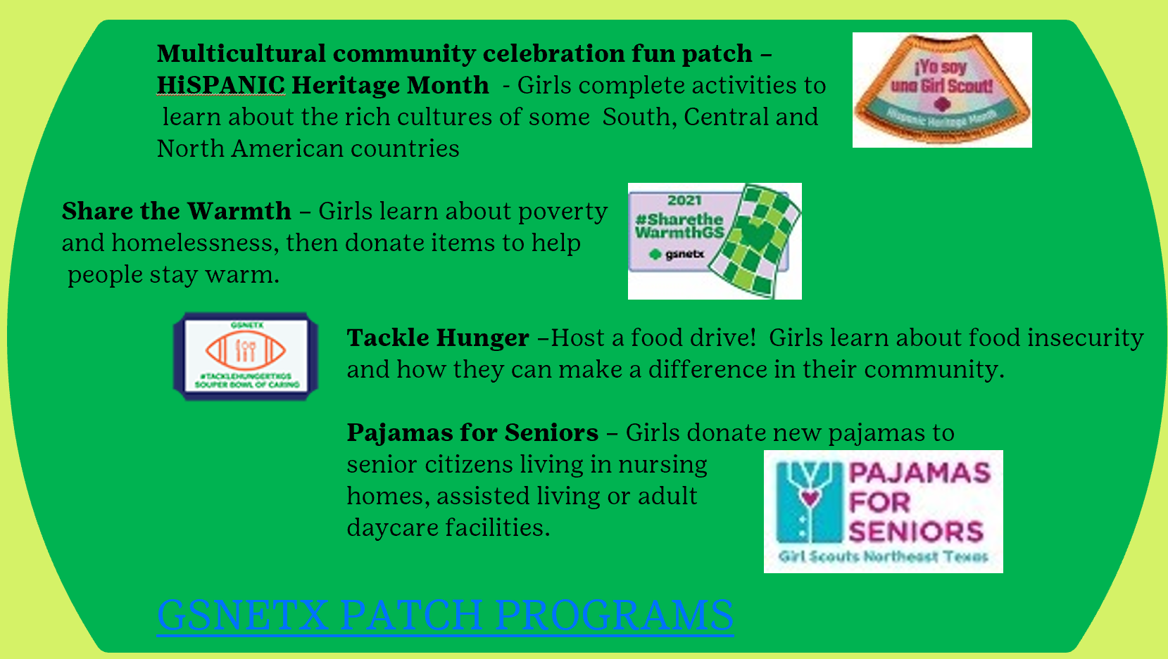

MARK YOUR CALENDARS

GET THE SCOOP, STAY IN THE LOOP – VIRTUAL NEW LEADER MEETINGS

10/26 7 PM 11/16 7 PM 12/14 7 PM
10/27 NOON 11/17 NOON 12/15/21

IN-PERSON EXCLUSIVE NEW LEADER EVENTS
FEBRUARY 20TH, 1:30 -4 pm JOANN FOGG SERVICE CENTER
APRIL 10TH, NOON, CAMP WHISPERING CEDARS, STEM CENTER OF EXCELLENCE

